**New Disagreement Measure (Guttman, Kandel, Rooz and Shaton)**

**Three time periods:** *1983-2000, 2001-2009 , 2010-2021.*

*Note, that since our disagreement measure is deflated by the average prior dispersion in the same quarter for the last three years, you should extract data for additional prior three years (i.e., 1980-2000; 1998-2009; 2007-2021), but present results for the above years.*

***Datasets:***

1. *Analysts’ forecasts of EPS extracted from IBES detailed file.*
2. *Daily adjusted stock returns; adjusted price; adjusted shares outstanding; adjusted short interest; and adjusted volume are retrieved from CRSP.*
3. *Earnings announcement dates from COMPUSTAT, quarterly data.*
4. *The exact time (in addition to the day) of earnings announcement is extracted from IBES Guidance.*
5. *S&P 500 index daily trading data from CRSP – this will be used to identify announcement days that are not trading dates.*
6. *Linking tables.*

***Screening requirement****:*

* *We Include only US firms.*
* *We Include only EPS analysts forecasts, for fiscal year 1.*
* *We Adjust EPS forecasts to splits (i.e., using adjustment factor from CRSP)*
* *Drop analysts forecasts with announcement date (ANNDATS) greater then the forecast period end date (FPEDATS)*
* *We require coverage of at least five different analysts for each stock during the two days after earnings announcement (i.e., we include only analysts forecasts that were announced at the day of earnings announcement, but after the time of earnings announcement since we know the exact hour, and the following day after earnings announcement).*
* *For robustness test we require coverage of at least five different analysts for each stock during the five days after earnings announcement (i.e., we include only analysts forecasts that were announced at the day of earnings announcement, but after the time of earnings announcement since we know the exact time, and the following 4 days after earnings announcement).*
* *If there are two forecasts by the same analyst in the 2 (5) day window we include only the first forecast by the same analyst.*
* *Stocks with share price lower than 5 dollars are omitted.*
* *When there are two types of securities for the same firm we take the most liquid one (i.e., with highest volume)*
* *When earnings are announced in a non-trading day we take the first trading day following the announcement day.*

***Estimate our Disagreement Measure:***

As DMS and others, we base our measure on the standard deviation (dispersion) of the analysts’ forecasts of the annual EPS. The difference is in how we compute and normalize it. We conjecture that in the short window following the earning announcement, there is a lower probability of other significant public information releases. At the same time, many analysts issue new forecasts during that window, eliminating the problem of stale forecasts. Thus, we only use forecasts issued during the first 2 (5) trading days starting from the day of earning announcement for stock *i* inquarter *q* of year *t*. We further conjecture that the level of dispersion contains a predictable component based on the identity of the firm, and the quarter. Thus, we scale the dispersion by the average of the standard deviations of analysts’ forecasts calculated for stock *i* in the same corresponding quarter *q* over the previous three years:

$$Unexpected Disagrement Measure_{i,q,t}= \frac{{σ\left(eps_forecasts\right)}_{i,q,t}}{\frac{1}{3} \sum_{j=1}^{3}{{σ\left(eps_forecasts\right)}_{i,q, t-j}}]}$$

This measure captures the unexpected change in disagreement, which can potentially drive trade. This is in stark difference with DMS, that measure disagreement as the standard deviation of analysts' annual EPS forecasts divided by the absolute value of the mean forecast, which captures the absolute level of analysts’ disagreement about the future EPS of a stock every month, without worrying about the predictability.[1]

***Calculate Cumulative Excess Return around EA***

*Calculate the cumulative excess adjusted return (excess over the S&P 500 and adjusted for dividend and splits), for day 0 and day t+1 after EA, for each firm quarter observation. Also calculate the absolute value of the cumulative excess adjusted return.* Winsorize both variables at 1% and 99% of their distribution.

***Calculate Buy and Hold Return Following EA***

Calculate the buy and hold excess return for a firm-quarter observation in the 21 trading days after EA (i.e., from day +2 to day +22 after EA), and separately for the next 21 trading days EA (i.e., from day +23 to day +43 after EA).

***Calculate Abnormal Volume***

Abnormal volume is calculated in a similar manner to Livnat & Lerman (2009) and Collins et al. (2009):

We estimate abnormal trading volume as average daily share trading volume over the event period divided by the normal daily share volume during the non-event period. The event period is the two days after earnings announcement (i.e., day 0 and day +1 after EA. Day 0 is the EA day). The non-event period is taken to be days -52 through -8 relative to earnings announcement date (but we make sure that these days do not include the two days after the prior quarter EA day). Thus, we designate the abnormal volume for firm i at earnings announcement of quarter q in year t as:

$${ABVOLUME}_{i,q,t}= \frac{{AVG}_{d ∈\left[event\right]}{[VOL}_{i, q,t,d}]}{{AVG}_{d ∈\left[non-event\right]}{[VOL}_{i, q,t,d}]}-1$$

where periods are as indicated above, and ${[VOL}_{i, q,t,d}$] is the daily trading adjusted volume in millions of shares on day d obtained from CRSP. The abnormal trading volume measures the percentage of change in daily trading adjusted volume during the event period relative to the non-event period. We exclude observations where the average volume in the non-event period is equal to zero. winsorize at 1% and 99% of their distribution.

**Calculate volume and short interest over shares:**

* Calculate the daily volume over the number of shares outstanding (for this measure you do not need to use adjusted volume or shares since we use the same day data to construct it), for each of the 60 days after EA (i.e., day +2 till day +60 after EA):

${VOLUME_OVER_OSHARES}_{i,q,t,d}= {VOL}_{i,q,t,d}/{SHROUT}_{i,q,t,d}$

* Calculate short interest over the number of shares outstanding at the day of short interest (again, for this measure you do not need to use adjusted data since we use the same day data to construct it), for each of the 60 days after EA (i.e., day +2 till day +60 after EA):

$${SHORTINT_OVER_OSHARES}_{i,q,t,d}= {shortint}_{i,q,t,d}/{SHROUT}_{i,q,t,d}$$

Start by presenting the following tables (I would like to make sure that our results are the same. Once we are confident that the calculations are correct, I’ll send additional tables that we’d like to generate):

***Replicate Table II, Panel A and B, of DMS using our disagreement measure:***

*Calculate a portfolio strategy as follows: each quarter stocks are sorted into five groups based on the level of market capitalization of the previous quarter. Stocks in each size group are then sorted into five additional groups based on our disagreement measure for the previous quarter. Stocks are held for one month. Calculate the monthly portfolio adjusted return as the equal-weighted average of the adjusted return of all the stocks in the portfolios.*

* *Show replication of table 2, Panel A (mean returns) for all the stocks with fiscal year-end of December, for the period 2010-2020. The return are the mean of the buy and hold return for 21 trading days after EA.*

***For Illustration: Table 2 of DMS (1983-2000)***

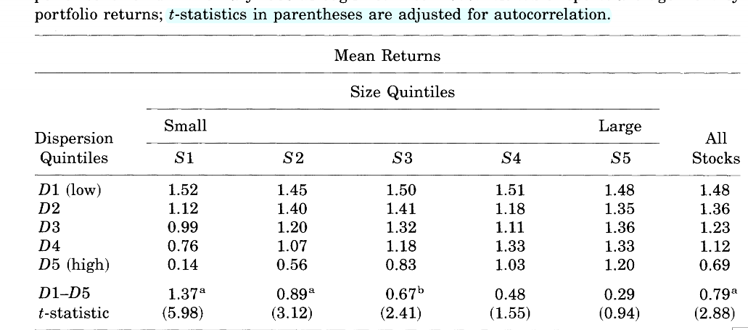

* *Show replication of table 2, Panel B (mean dispersion) for all the stocks with fiscal year-end of December, for the period 2010-2020.*

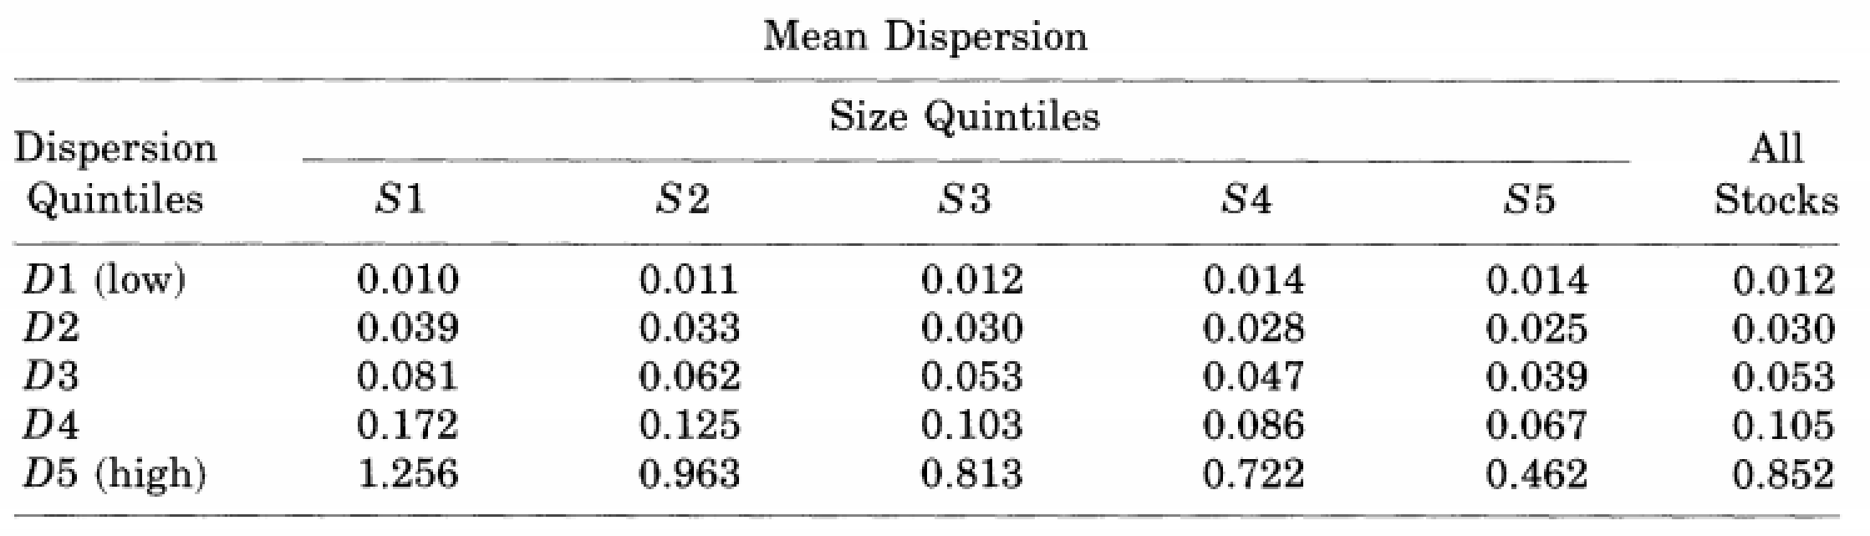

* Calculate a transition matrix (i.e., the probability of a firm switching between dispersion quintiles from one **quarter** to the next). Show a transition matrix for firms with December as fiscal year end.

1. Berkman et al. (2009) and others also use the level measures without the discussion of predictability or public information arrival.